**P1 – Describe different network technologies**

**Scenario**

In a format of your choice, for example blog, report or web pages etc. describe different network technologies.

* Network technologies: *operating system; protocols; layout; devices*
* Network operating systems: examples e.g. *Windows, Linux*
* Layout: e.g. *cabling, topologies, wireless*
* Network devices: *servers; workstations; interconnection devices; network cards; vendor specific hardware*

**Network Technologies**

**Operating system**

An operating system is a software that is a baseline support, which a computer requires for it to work. An example could be Windows. They are many basic support lines that the operating system does. This is distinctive with other operating system e.g. Linux and Windows.

This is important because an application usually requires an operating system to function. Therefore, the purpose of having an operating system is that without an operating system, it will not work. It is like a backbone to the computer and if it does not have that, it will not work. An operating system functions by controlling the peripherals, starts the computer, manages programs, security for the computer e.g. password, manages the memory, accessing the web and controls the web. Modern networks contain a complex structure, which is designed to network a computer. Network operating system can be used to share files through email. It can be run through client server or peer-to-peer network.

**Protocols**

It’s within a computer, a communication protocol is a system which plays a part of exchanging messages within or between the computer. The main protocols that are involved in the OSI layer is the following: HTTP, TCP, IP, TCP/IP and Hardware. They are many types of protocols, but these are the main and simple protocols that people should know.

**Layout**

**[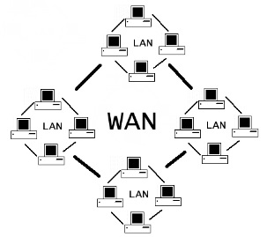](http://www.google.co.uk/url?sa=i&rct=j&q=&esrc=s&frm=1&source=images&cd=&cad=rja&docid=y2VpMOP4yg2KoM&tbnid=p2o1k6Uyr82ZBM:&ved=0CAUQjRw&url=http://technoxone.com/networking/different-types-of-networks&ei=IB7ZUpbBK-7s0gWJl4HgAw&bvm=bv.59568121,d.ZG4&psig=AFQjCNHK1-dK7LA8koJm_ZK4sguV1RMGtg&ust=1390047122507672)WAN** stands for wide area network. This connection can cover through a country. The advantages of using WAN, as a network is it can cover a wide geographical area. Anyone can use it and data can be shared through it, either it can be anything. The disadvantage of using WAN is that it is usually expensive to build up, because it covers a large amount of space. It is slow as if someone from one part of the country is using the network and the person is trying to send data, it would be slow. The bigger the network, the more expensive it is and the structure becomes even more complex. Especially for WAN, security is a big issue. Because this covers the whole country, many people can have access to this network. Therefore, they can use the information from this network. Protection is very important and if it is not secure, viruses and hackers can gain access to the network. Once setting up the network, it is someone else’s full time job to maintain the network and ensure no errors/issues have be found. Referring to Figure 1.1, this image shows how a WAN is presented.

Figure 1.1

**WAN Technologies** have three different types; ATM, frame relay and MPLS systems. ATM stands for asynchronous transfer mode and MPLS stands for multi-protocol labelled switching. Frame Relay is used at the core of WAN. This is important because multiple systems can communicate at the same time. MPLS system is like a traffic monitor. If the ‘traffic’ gets congested, it can ensure that it doesn’t get overloaded. It speeds up the network technology and it works with Frame Relay, ATM and internet protocol. Frame Relay is a telecommunication service that are designed for cost-effective reasons.

[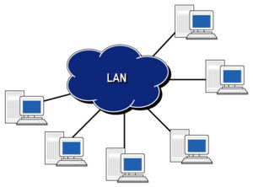](http://www.google.co.uk/url?sa=i&rct=j&q=&esrc=s&frm=1&source=images&cd=&cad=rja&docid=B3QSgsctIb3yZM&tbnid=UDAYmes2XCD-vM:&ved=0CAUQjRw&url=http://www.hill2dot0.com/wiki/index.php?title=Local_area_network&ei=tx3ZUv_7AcSb0QXz7ID4CQ&bvm=bv.59568121,d.ZG4&psig=AFQjCNGJrlBRqrrqylCLe3DDZRiTNyK4bQ&ust=1390047012440464)**LAN** stands for local area network. It says in the name ‘local’. LAN can be used for colleges, schools, universities. The advantages for LAN is that the local area network set up is cheap. In addition, users can transfer data easily. The connection should be relatively fast as they are all connected to the same network. If one workstation crashes or the network does not work, others will not be effected. On the other hand, the disadvantage for LAN is in every problem for network. The security for network is a real problem. Once a person finds out the password that is set for the network, they could get access with all the information that is shared. If the password is successful, it could do a lot of damage to the whole network system. Both workstations need to be switched on in order to transfer data.

Figure 1.2

**Figure 1.2** shows the diagram on LAN. This is different to WAN because LAN is just used for a local area, whereas WAN covers as much as a country.

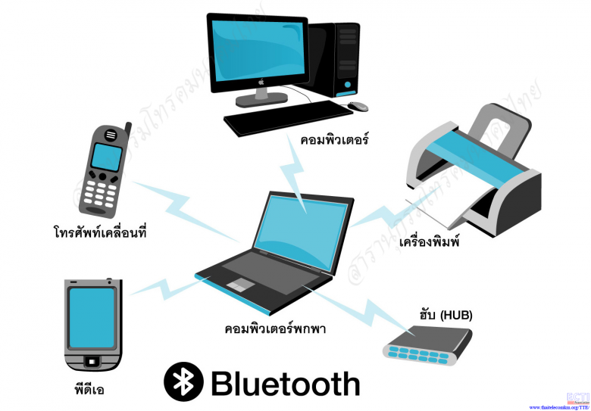**A PAN** is any personal systems that is a network. If you have internet at your house, this is a PAN network. They are technologies that can be used such as PDAs, Bluetooth, wireless USB. Bluetooth uses short-range waves that can cover up to approximately 10 metres. Within 10 metres, you can transfer data. Bluetooth can be used in mobile phones, headsets, printers and many more. This is used for personal reasons. Therefore, if you want to use/communicate with another person, you can communicate with him or her as this is a PAN. The most common people use nowadays is that they connect their headsets with their mobile phones. Therefore, if any calls come in, they can answer it using their headset. Referring to figure 1.3, this image shows the other options Bluetooth that can connect with each other. The advantage for PAN is that users can move around with their mobile phones. However, the disadvantages is that the PAN is limited to the area of 10 metres.

Figure 1.3

[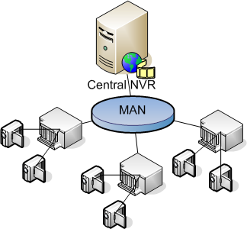](http://www.google.co.uk/url?sa=i&rct=j&q=&esrc=s&frm=1&source=images&cd=&cad=rja&docid=IDJFRnKLVStD1M&tbnid=lq6rOtYmWM-yfM:&ved=0CAUQjRw&url=http://tipsshared.blogspot.com/2013/01/pengertian-dan-fungsi-man.html&ei=MjHZUte2IamV0AWb-oDQDw&bvm=bv.59568121,d.ZG4&psig=AFQjCNFhGGBjMz-xdmv6c_B7GKqf4BZGcQ&ust=1390051997355194)**MAN** stands for metropolitan area network. This is a computer network that is specifically designed for cities or towns. MANs distance is greater than LANs but not as big as WANs. The biggest advantage for MANs is that it has a very high-speed. This is fast as they are trying to use more Ethernet cable method than a fibre optic cable as Ethernet provides faster connection. This means that when someone is transferring data, it would be very quickly. The disadvantage of MANs is that it can be very costly. This is most common to be used on university campuses. Referring to Figure 1.4, this image shows that the WAN is connected to university/ buildings and it only covers a city.

Figure 1.4

**VAN** stands for value added network. This is a private computer network that is hired by companies to transfer data from one end to another. Before the World Wide Web was released companies hired value added network to exchange data. This is important for businesses, as it is faster when information passed on to other person it is fast. This is important as it reduces paper work for businesses and ethically, it saves paper. The cost of installation is a disadvantage for businesses as it may be expensive to install. VANs have a history as it were used back in the 1960s to 1980s.

**Network operating systems**

**Windows**

Windows is a type of operating system that does what you need it to do. The features for Windows is that the start screen differs from other Windows. This is the latest Windows and it shows all the applications that you can use on the computer. By browsing Mail, you can check your emails. In addition, you can split the screen and work on two applications at the same time. In addition, you have theability to customizethe theme/colour of the desktop and the start screen. It comes in any colours and designs. The security for Windows differs from each operating system. From Windows XP – 7, they have included a password to log into the account. Windows 8 has that option but includes a four-digit pin. Both of them are safe as long as it is not easy to figure out. Having an anti-virus is important as it reminds you when you need to scan for viruses. This supports the computer as it can detect any viruses and delete them of the computer.

**Linux**

Linux is different from any other operating system. It has its own style and it is not as popular as Windows. Linux has many capabilities, which allow people to create their own layout like the picture shown, which also allows the user to set the operating system to his needs that Windows 7 cannot do which makes it less desirable to some people. In addition, Linux has features that allow you to code more efficiently then windows 7 because it is created for people who want to code and learn more about operating systems but windows 7 does not allow users to do this.

**Layout**

**Cabling**

Cabling have different types. They are many types of cables that can be used for a network technology. However, I am going to be talking about two of them; and they are shielded cabling and fibre optic cabling.

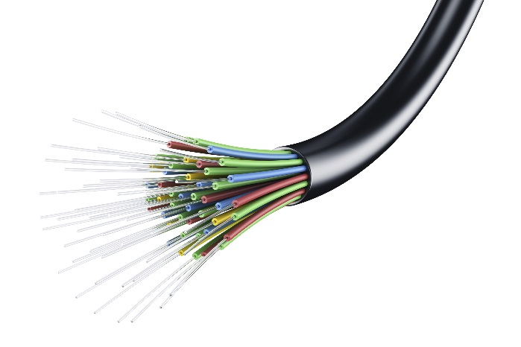**Fibre Optic** cabling contains dozens of strands. Approximately, each strand is as thin as one human hair. If it were that thin, it would take time to cable. Therefore, the disadvantage is that it would need professional person to insert these strands and cable it in. However, the advantage is that it transmits data through light rather than electricity. Shielded twisted pair cabling has a protective layer rapped around the cables to prevent it from making noises. In addition, shielded twisted pair cabling can carry data at a faster speed. However, it is expensive and it is more difficult to work with.

*Ethernet* cables travels at a rate of 10Mbps and the distance of 100M. It has variety of Ethernet cables, which go faster, and this determines how fast the travel will go from one computer to another.

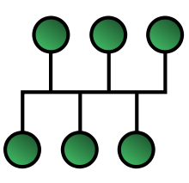**Topologies**

**Bus** topology has a backbone where all the computers are connected to it. Figure 1.6 demonstrates the backbone where all the computers are connected to it. The advantages for using Bus topology is that it costs less. This is easy to set up and the extent of the network could be huge. In addition, it is good for local area network (LAN) because it is used for small networks such as LAN. There is a lot of dependency on the main cable. The problem with that is if the main cable comes across some problems, it could affect the whole network. In addition, there is a limit to number of nodes that could be connected to this network.

Figure 1.6

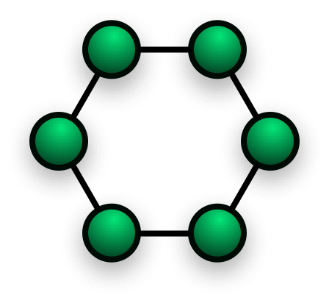**Star Topology** is all the nodes have been connected to one individual computer. Therefore, this becomes a shape as a star as that is where it got its name. A star topology is commonly used in homes and offices. This is one of the popular topologies. The advantage of using star topology is that it is installed quickly. As it is connected to a central hub, the performance does not affect other computers because it is not connected to them. Therefore, replacing any nodes is very easy, as you are not disturbing any other computers. In addition, if any problems occur, the central hub will pick it up and it will be traced easily of which node is the problem. On the other hand, if the central hub’s servers were slow, it would affect the performance of the other computers. It takes many cables to set up the network. Referring to Figure 1.5, it shows how star topology looks like. As you can see, all the computers are connected to one computer.

Figure 1.5

[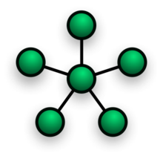](http://en.wikipedia.org/wiki/File:NetworkTopology-Star.png)**Ring** is a topology that has nodes (workstations or other devices) that are connected with each other as they makes a sphere ‘ring’. The advantage of using ring network topology is that data is transferred very quickly, but it must be passed through all the computers to reach to the receiver. If any node fails, any sender cannot receive any data, as it will be interrupted with the failed node. To add another node between the rings, you must shut all the nodes down temporarily for the cabling to occur. Again, this is as same as any node failing. If the node is not switched on, data cannot be passed, as it needs to pass through all the nodes to receive to the node. Referring to Figure 1.7, this shows us how ring topology looks like. The green dots could be represented as nodes.

Figure 1.7

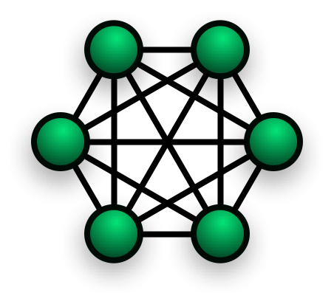**Mesh** is a topology has many connections in between the nodes. It looks similar to Ring topology but has connections in between. They are two different types of Mesh topology, full mesh and partial mesh. Full mesh has every node connected to each other whereas partial mesh has one or two nodes connected. The disadvantage for Mesh is that depending on how many nodes are connected with each other, it costs either more or less. Without disrupting nodes, expansion can be made easily. As they are many connections and cables between these networks, it is very hard to set up. Referring to Figure 1.8, this shows how a Mesh network could look like.

Figure 1.8

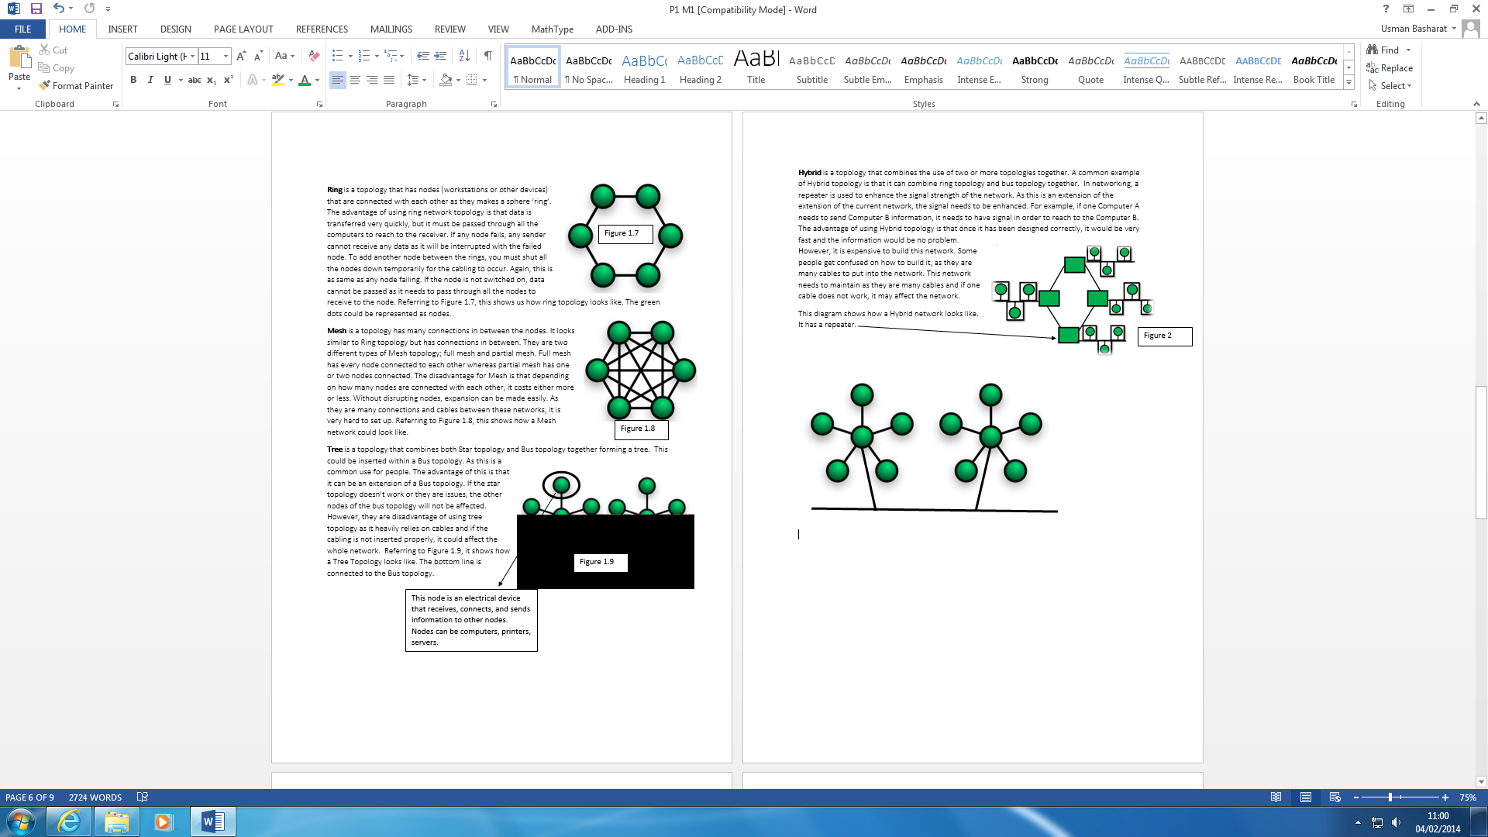**Tree** is a topology that combines both Star topology and Bus topology together forming a tree. This could be inserted within a Bus topology. As this is a common use for people. The advantage of this is that it can be an extension of a Bus topology. If the star topology does not work or they are issues, the other nodes of the bus topology will not be affected. However, they are disadvantage of using tree topology as it heavily relies on cables and if the cabling is not inserted properly, it could affect the whole network. Referring to Figure 1.9, it shows how a Tree Topology looks like. The bottom line is connected to the Bus topology.

Figure 1.9

This node is an electrical device that receives, connects, and sends information to other nodes. Nodes can be computers, printers, servers.

**Wireless**

It is implemented into mobile phones or any sort of device that is used wirelessly. So, that they can be used wirelessly without using Wi-Fi. It depends on the provider – O2, Vodafone or T-Mobile – whether the connection has a good strength or not. The newest mobile technology is 4G. It transmits data faster depending on the provider. The location could affect the signal. If you are in a school, where normally signal is weak, the data transmitted would be slow/or would not work.

**Network devices**

**Workstations**

Workstations is a desktop computer that typically is networked used in a professional workplace or in a business. Workstations is not your local computer. It has:

* More cables
* Faster

It uses many cables for it to be connected to use the internet. A commonly found device that is connected to a network infrastructure. The term workstation has changed during the years. The aim of a workstation is to connect users to other users around the whole wide world. These workstations are run on an operating system e.g. Windows, Linux or MAC OS. The aim of using an operating system is to allow users to get access from another computer but the same place. An example of a workstation could be a computer. Nowadays, workstations can be used as a handheld phone:

* PDA
* Blackberry
* PSP

**Server**

Server could be a computer system that manages, responds or helps other users from a network service. Servers could be run on a computer. This enables other workstations (and other servers) to offer a dedicated server to them. The hosting server is the manager of the server. He only can access to all the materials, which other workstations cannot access. Some of the servers you may come across are:

* Chat and discussion servers
* Game clan management servers e.g. Minecraft
* Security servers
* [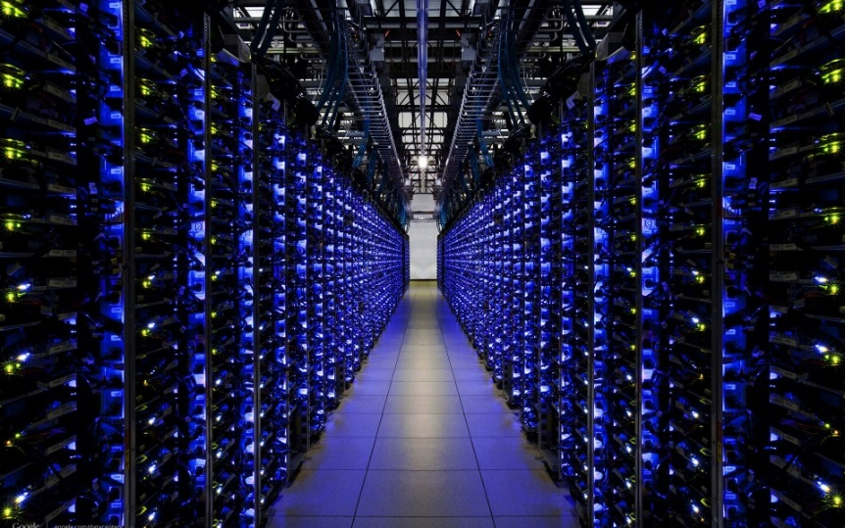](http://www.google.co.uk/url?sa=i&rct=j&q=&esrc=s&frm=1&source=images&cd=&cad=rja&uact=8&docid=Iy-akGclrhlxgM&tbnid=OWcrsrW78v5UkM:&ved=0CAYQjRw&url=http://infiniox.com/cloud-servers-registered-until-2017-for-infiniox-com/&ei=mPomU6sY04OFB7ePgTg&bvm=bv.62922401,d.ZG4&psig=AFQjCNHBCAX2HAj3P_LrNUB3muLal4r48Q&ust=1395149840452732)Web servers

Some of the servers have requirements that you may need to get access to the server. For example, when you want to play Minecraft, you have to be connected with the internet for you to play with others. This is important, as having an internet connection is one of the main requirements. Referring to Figure 1.1, it demonstrates how the Cloud server looks like. It has many cables and devices for it to be connected.

Figure 1.1

**Interconnection devices**

An interconnection device are three of the below: router, switches or wireless access point (WAP). These are also the devices of them.

**Router**

A router is a device that takes incoming segment of data sent from over two networks. The data transmits through the router. It sends the data from the current location through the router to the destination it supposes to go. It tracks the destined location by using its IP address. Routers can be found in houses and small offices by passing data e.g. email. When the data has been sent, the router tries to find the best possible route to transmit the data. Wireless routers could be slow depending on where the computer is set in the house or small office.

**Features and Functions**

The internet transfers data using TCP/IP network, which is established for internet to communicate with each other. A router’s basic feature is to connect two networks together by transferring data. When data is send from one location to another, it is called ‘packets’. The function of the router is to ensure that the data has been travelled to the destination safely. It manages and controls the transferred data during the process. This is important as if it fails to transfer data, the transfer data would not reach the destination. Referring to figure 1.1, it demonstrates the diagram of a router. Each socket has its own job.

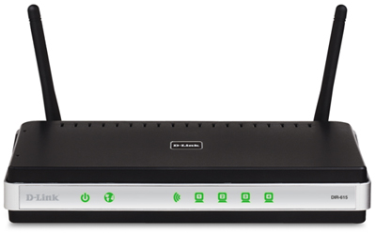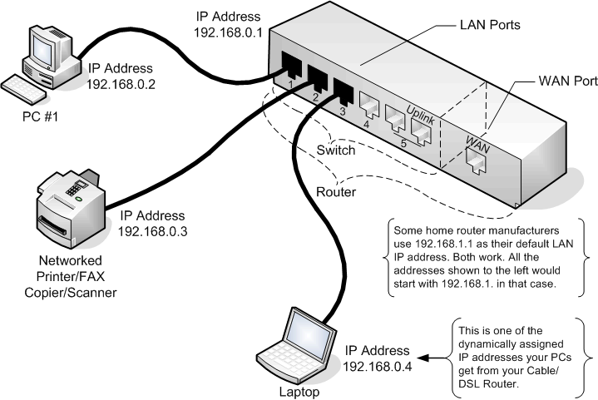

Figure 1.1

Figure 1.2

**Switches**

A switch is a device that connects computers together. It could be used in homes or small offices. The purpose of a switch is to enable communication between the connected computers. The users could share resources with each other as only the connected pair are allowed to access these resources. In a small business, using a switch is appropriate because they will need to pass around information to each other.

**Features and Functions**

The features of switches is that it can connect more than one computer at a time. It is similar to a network hub, but it is considered more “intelligent” than the network hub. As they are more computers connected, the security network is secured. It goes as a flow and it is more efficient. The functions of switches is to prevent collision between the computers that are connected with each other. For example, if around five people try to send information to each other, it will probably crash the network. The role of this switch is try to prevent the collision of the computers or transfer of data. Referring to figure 1.3, it demonstrates how the connective process between the computers process.

This is a switch. The more ports it has, the more computers the user can connect.

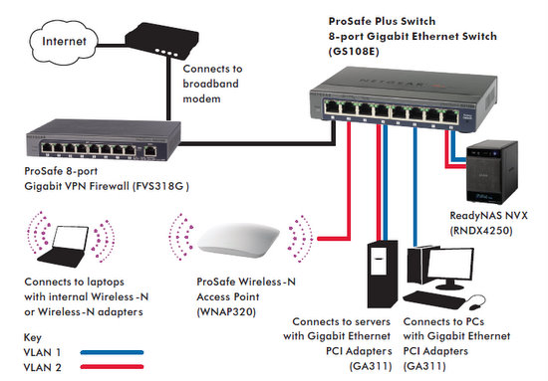

Figure 1.3

**Wireless Access Point (WAP)**

A wireless access point allows accessing the network wirelessly. It acts like a centralised source that transmits data and receives it. They are no cables involved. Therefore, the purpose of a wireless access point is to transfer data without using cables. More than one user can connect, but it has a range. If you are close to the access point (AP), you will transfer data faster. The more you move away from the AP, it is likely you might get disconnected.

**Features and Functions**

The features of a wireless access point is that it can connect many devices at once. Obviously, the connection might be slow but if the user uses it at the right time, it may enable fast activity. It can connect laptops, desktop PCs, tablets, printers and mobile phones. The role of a wireless access point is that it mainly acts as switches to spread connections wirelessly. They only lock out traffic that does not have the wireless code. Referring to figure 1.4, it demonstrates how a Wireless Access Point is set-up. Within the circle, they can only connect to the internet and transfer data. If the access point is not within reach, you cannot connect to the internet. Moreover, you will need the network password to gain access to the connection. If you do not have the internet password, you cannot have access to the internet connection.

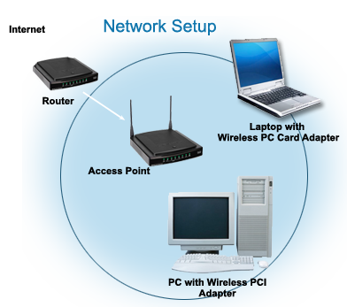

Figure 1.4

**Network cards**

**Network Card**

**Network card** is a card that is imbedded into the computer, which allows the computer to connect to the internet and other peripherals.

**Ethernet card**

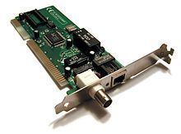Ethernet card is commonly known as network interface cards (NIC). This is used for communication in a computer across the internet for the IOS diagram. It is used in the data-link layer and physical layer. It is required for them layers to enable communication. It is on each computer connected onto the motherboard.

**Vendor specific hardware**

A vendor specific hardware is a supplier of hardware. This company provides servers to another company in need. Obviously, they need to be made before sending it off. For example, in NHS, they would need heart monitors, equipment that are essential for a human to detect whether his heart is beating or not. For people who get confused, ‘Vendor’ means a supplier or someone that is in need of this equipment. They could be many hardware, not just in the NHS; another company is in need off.